20th October 2017

**Italy Rally Due Valli: The Triumph Of Bruschetta In Group N**

*YOKOHAMA wins the national championship with the venetian pilot*

After the victory in the group N of the Italian Dirt Rally Championship, Alex Bruschetta and YOKOHAMA also gained the top spot of the group N table within the main Rally series (CIR).

The Rally Due Valli held last weekend offered the opportunity to the YOKOHAMA Trophy’s driver to win the national title in a tarmac race.

In the Group N, which is the category for base brand models, Bruschetta dominated throughout with his Subaru Impreza.

“I’m extremely satisfied with this result.” – expressed Giuseppe Pezzaioli, YOKOHAMA Italia Motorsport Manager – “Alex Bruschetta is our best discovery and our strongest bet, this year. He is not just very fast and constant on dirt he also proved himself with YOKOHAMA tarmac tyres. Alex has won everything he could with us: CIRT Group N and CIR. For further success and to win everything he just needs to finally obtain the YOKOHAMA Trophy in which he is the leader at the moment”.

For further information and updates on the YOKOHAMA Trophy please check:

<http://www.trofeoyokohama.it/>

<https://www.facebook.com/TrofeoYokohama/>

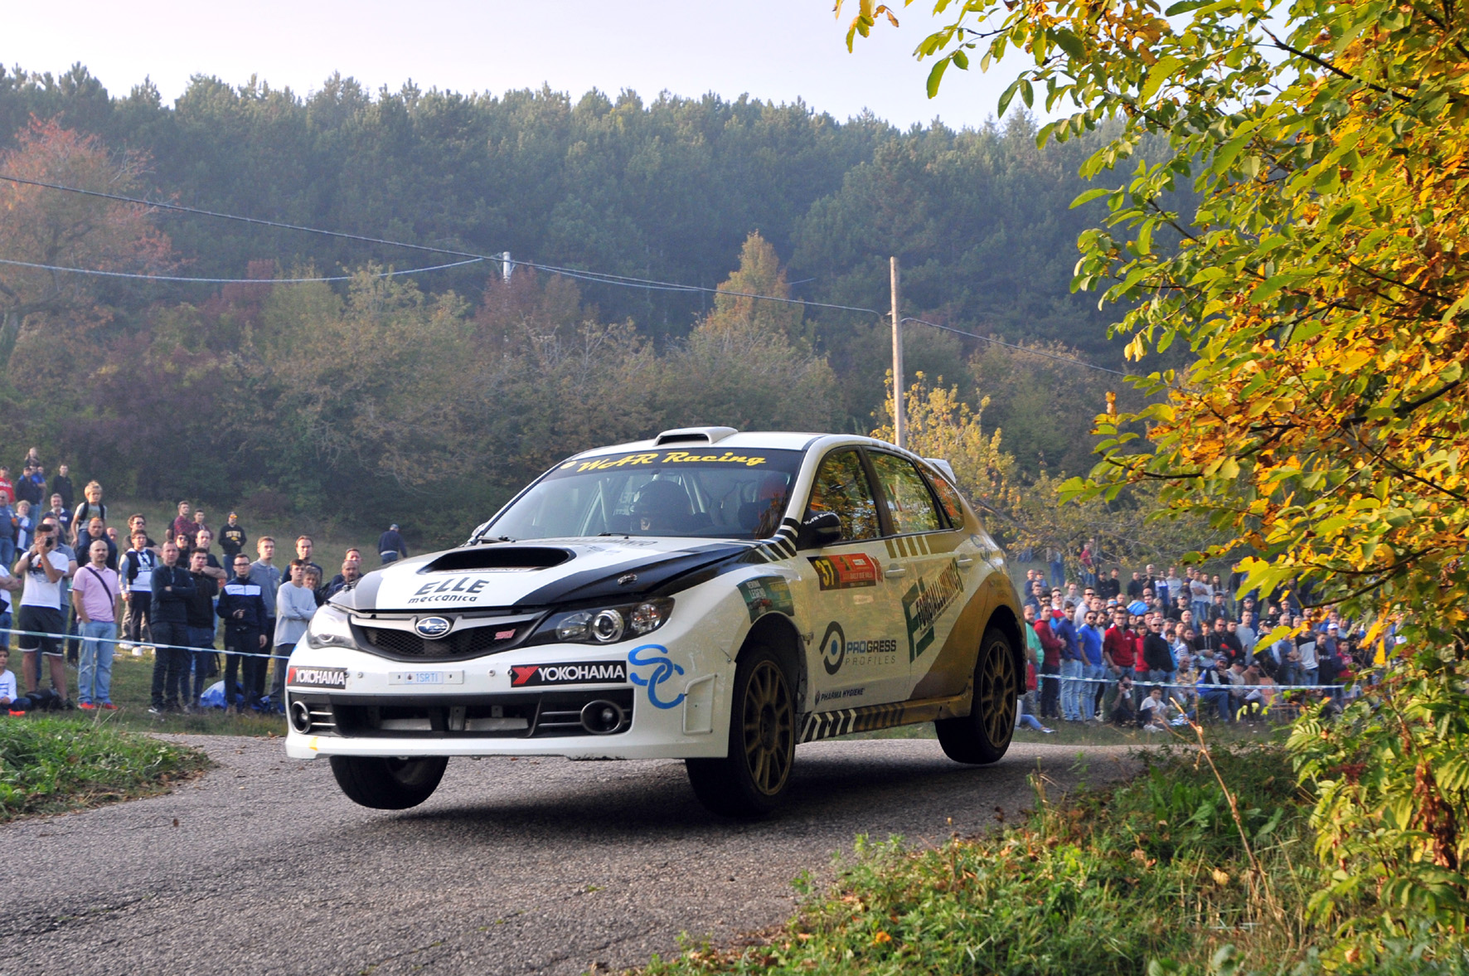

*Alex Bruschetta Triumps in Italian Rally with YOKOHAMA*